Git

====================

**Step1: Create a GitHub Account.**

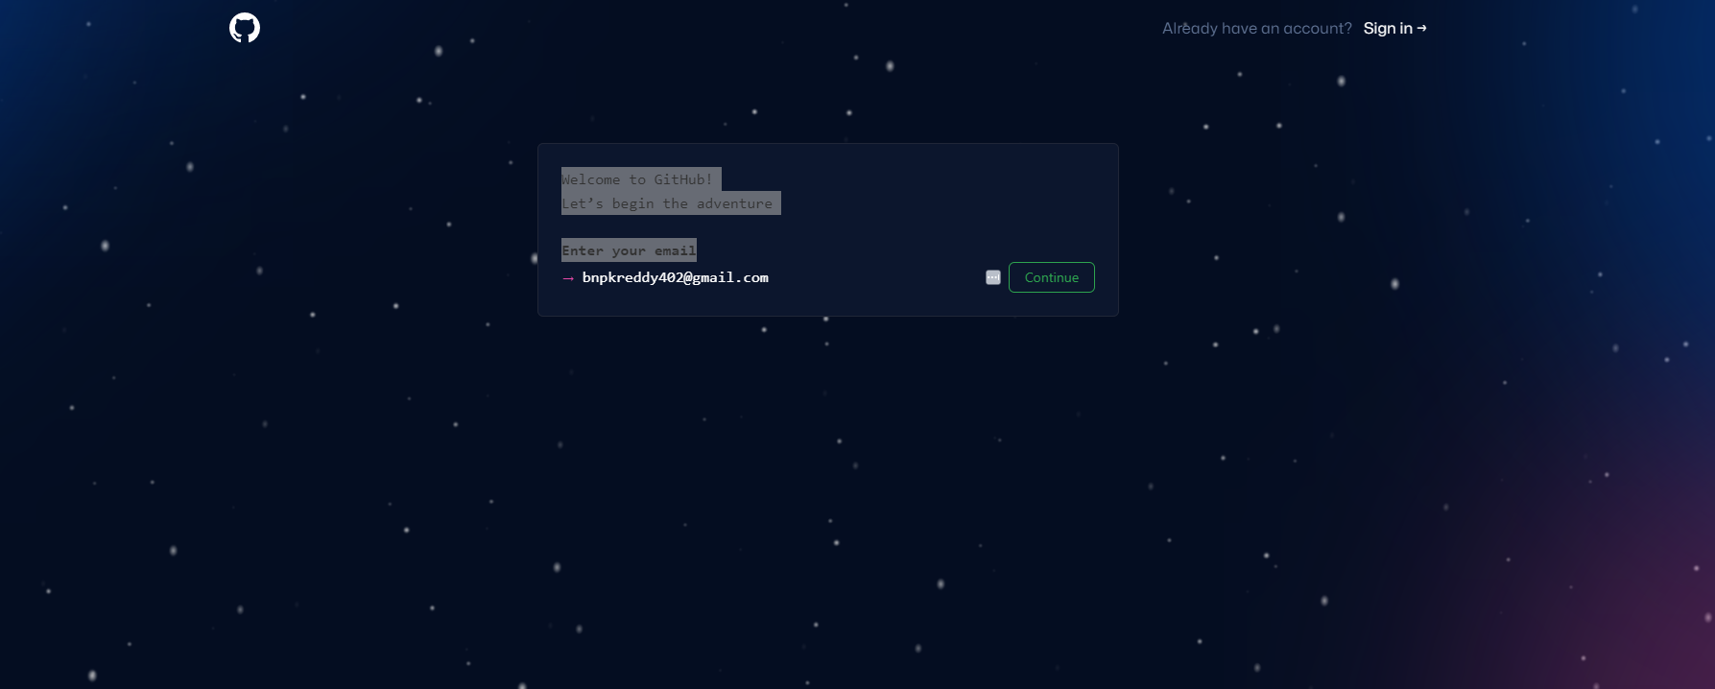

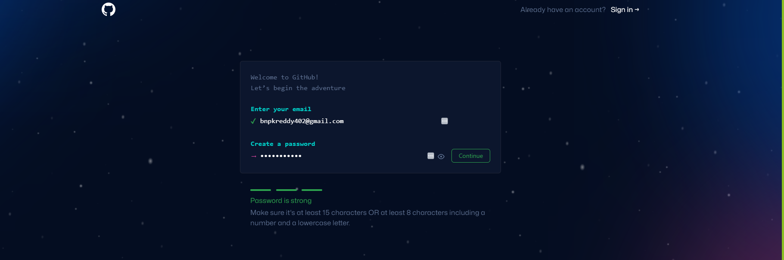

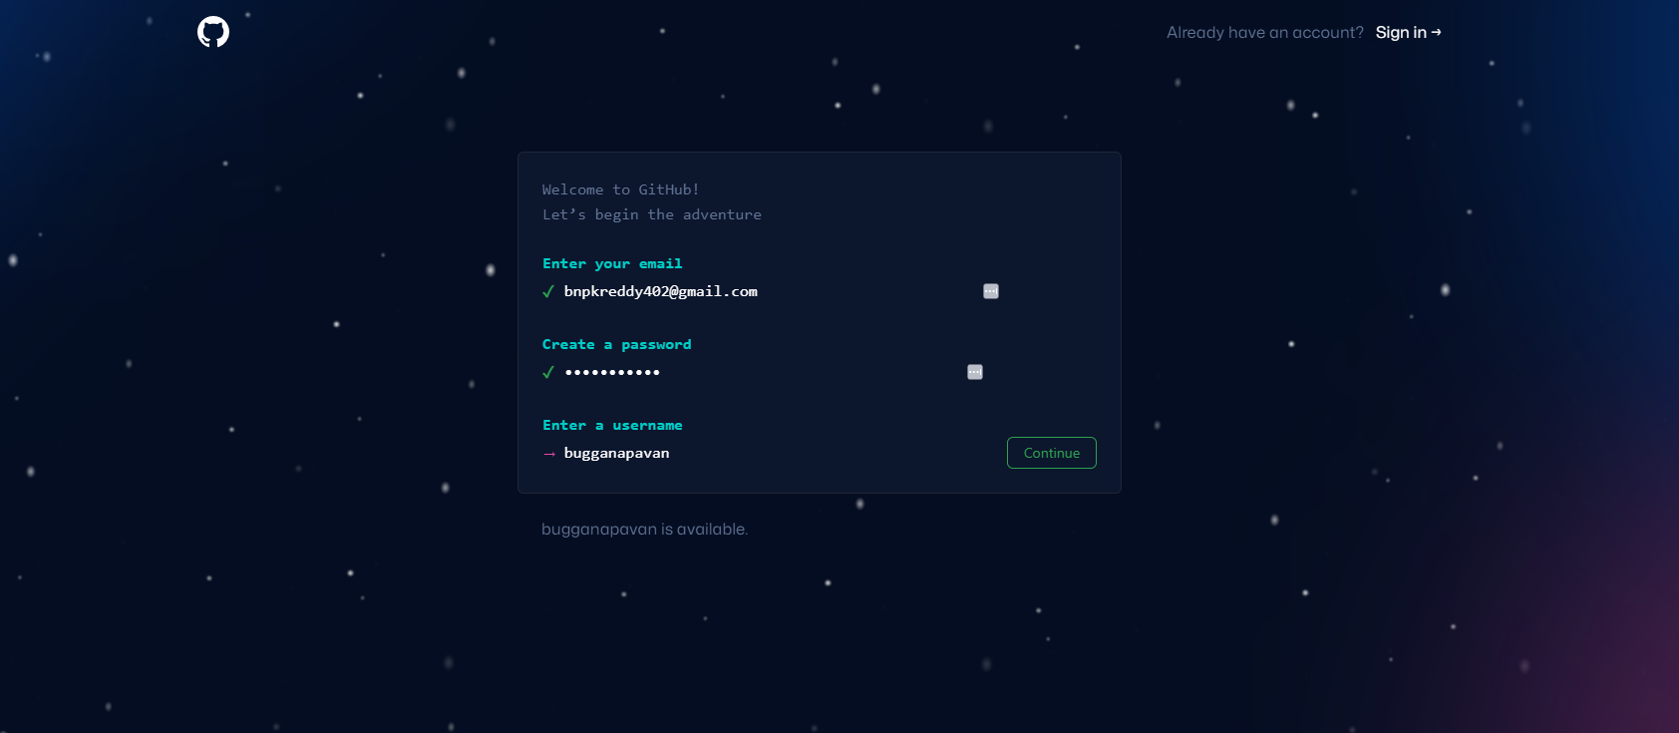

* **Asking to create an account.**

**Now its showing Git Dash board**

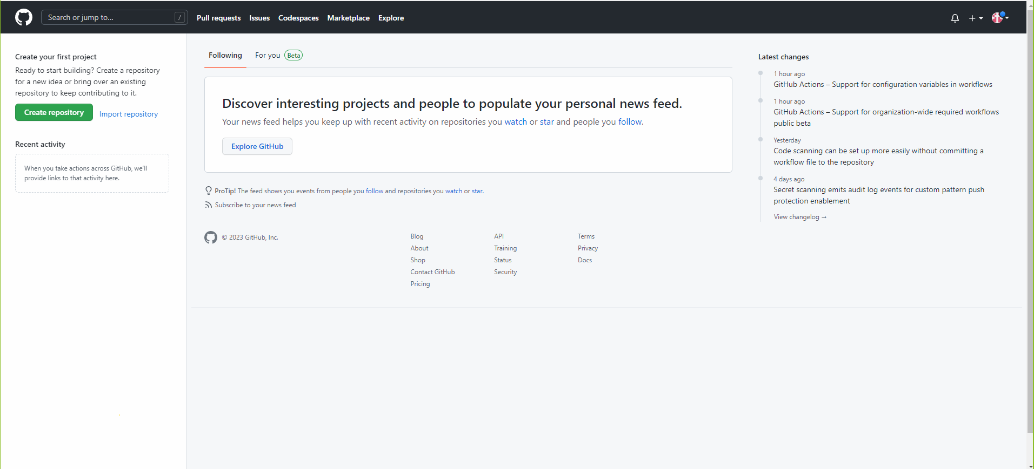

**🡺 After Creating Git Dash board, then create a repository.**

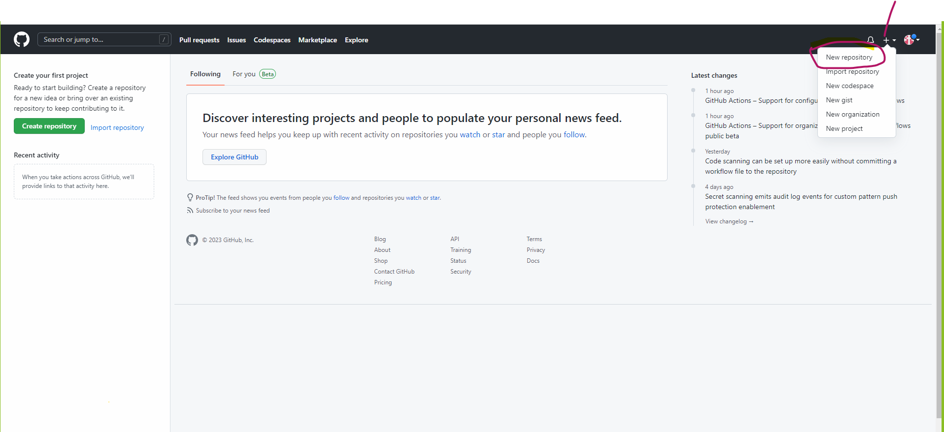

* **After Clicking on the Repository,**

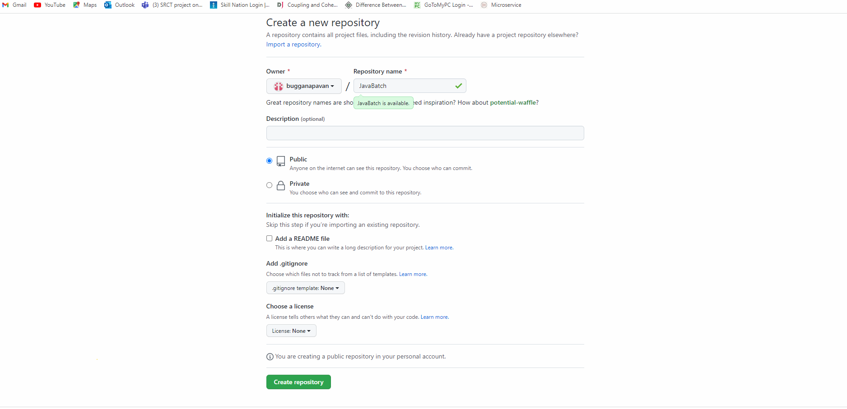

**🡺 Click on the create Repository.**

**🡺 After Creating Repository, It will show below fig.**

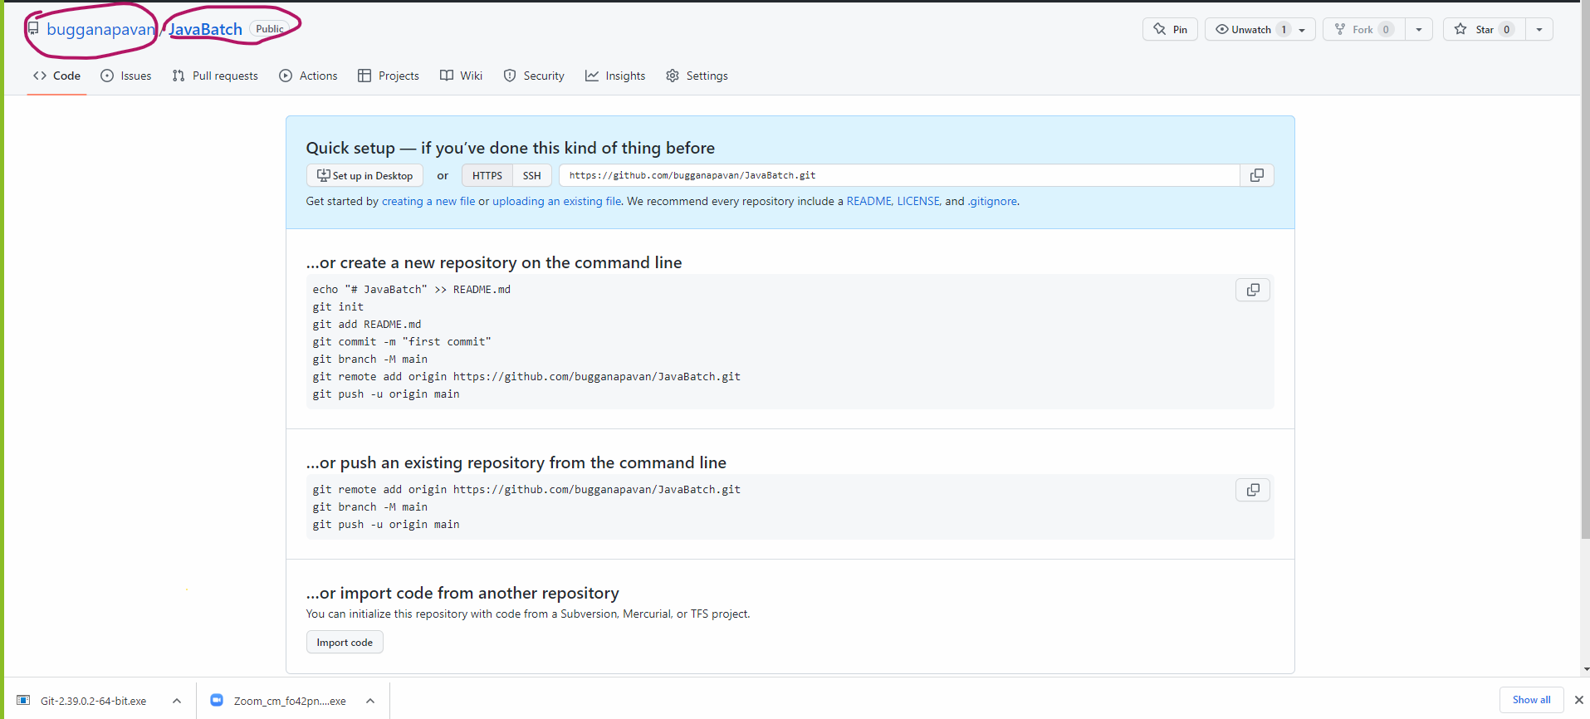

**=============================================================**

**🡺 Go to your project creation Folder,**

**🡺 Right click 🡪 it will show git Bash here**

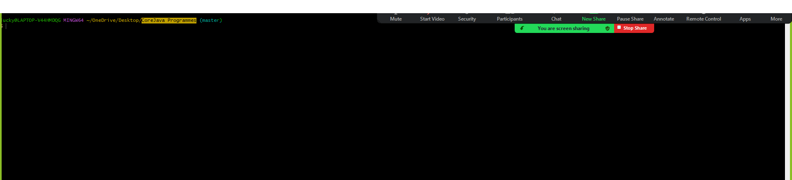

**Steps to push the code by using commands:**

**Command 1: git init**

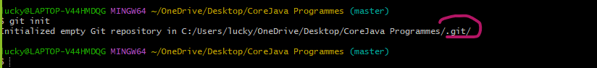

**Command 2: git status**

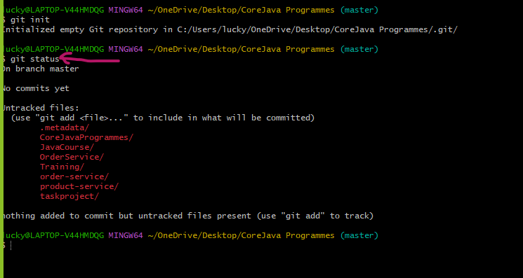

**Here we are getting untracked files. It will show in red color.**

**Command 3:- git add .**

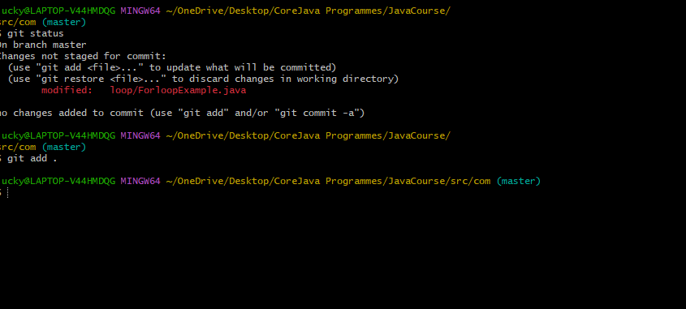

**Command 4: git status**

**Now check the status**

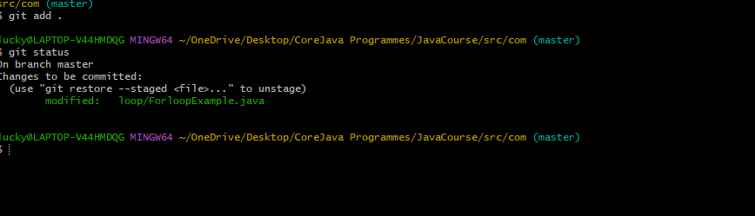

* **Now all the files will be tracked.**

**Command 5: git commit -m “added java files”**

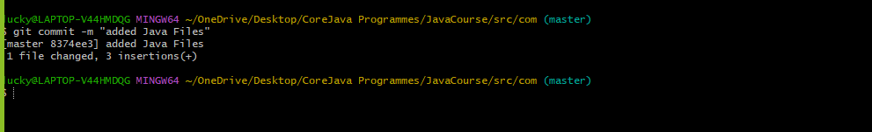

**Command 6: git remote -v**

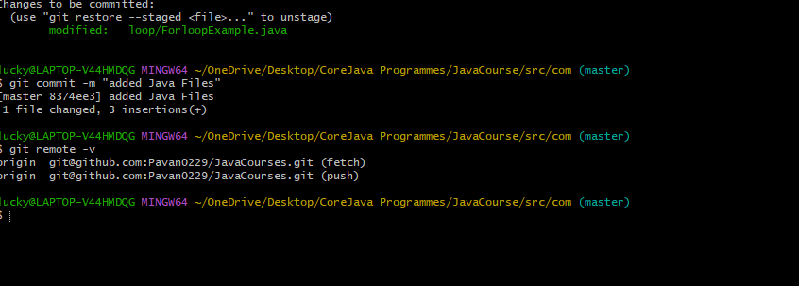

**If it is showing any Origins like pic:**

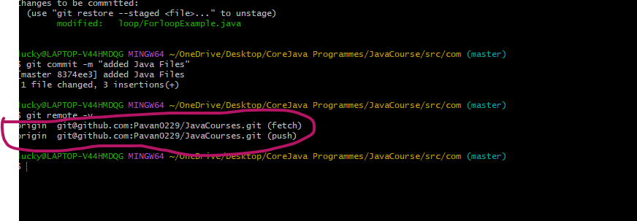

**Command:**

**git remote add origin** [**https://github.com/bugganapavan/JavaBatch.git**](https://github.com/bugganapavan/JavaBatch.git)

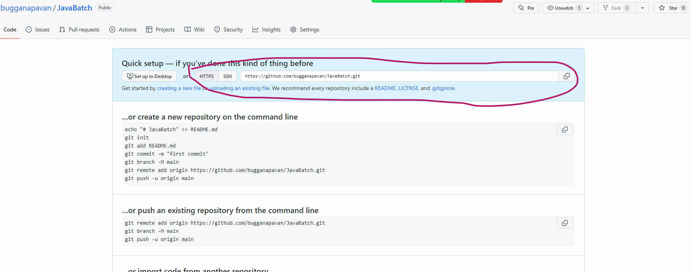

**Command: - git push origin master**

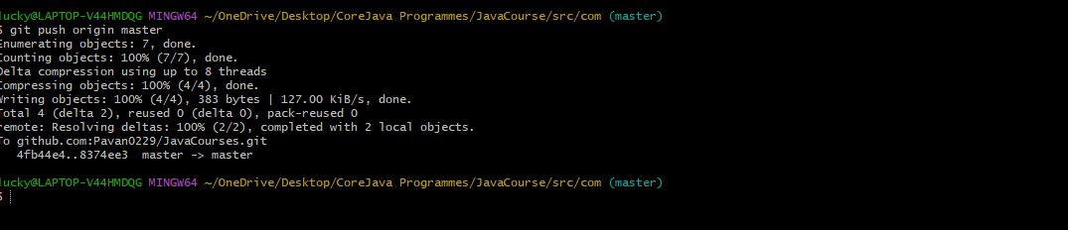

**Cloning the project by using below command**

**git clone https://github.com/bugganapavan/JavaBatch.git**